PDPO HK Compliance for Log360
Strengthen data protection and meet PDPO HK compliance with Log360.
Region: Hong Kong | Type: Data Privacy | Category: Compliance | Pricing: Free

Overview
The PDPO HK compliance extension in Log360 helps organizations meet the Personal Data (Privacy) Ordinance (Cap. 486, Hong Kong), Hong Kong's primary data privacy legislation enforced by the Privacy Commissioner for Personal Data (PCPD) for all organizations collecting personal data by providing centralized log management, real-time access monitoring, and threat detection. The platform supports PDPO HK requirements for data collection fairness, accuracy and retention, use limitation, security of personal data, openness, access and correction rights, privileged access management, and breach incident detection.
For DPP1: Data Collection Fairness and Lawfulness, Log360 monitors logon and access events across all environments to detect unauthorized or excessive data collection activities violating DPP1's lawfulness. To address DPP2: Data Accuracy and Retention Limitation, the platform monitors database modification events, file system changes, and audit log activities to detect unauthorized data alterations and identify retention of personal data beyond its required. The extension also supports DPP3: Use Limitation of Personal Data by providing capabilities that tracks user access to personal data repositories and database query patterns to detect out-of-purpose data usage and unauthorized disclosures that breach DPP3 restrictions.

Key Features
- DPP4: Security of Personal Data: Log360 monitors file access, database operations, and system security events across all platforms to detect unauthorized access to personal data.
- DPP5: Openness and Policy Transparency: Log360 monitors policy change events, configuration modifications, and administrative activities to detect unauthorized alterations to data protection policies undermining PDPO HK.
- DPP6: Access and Correction Rights: Log360 maintains audit trails of user account activities, data modifications, and access events enabling organizations to locate and retrieve personal data.
- Privileged Access and Data Processor Controls: Log360 records all elevated privilege operations, role changes, and administrative activities to enforce access controls over personal data.
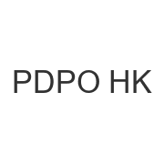

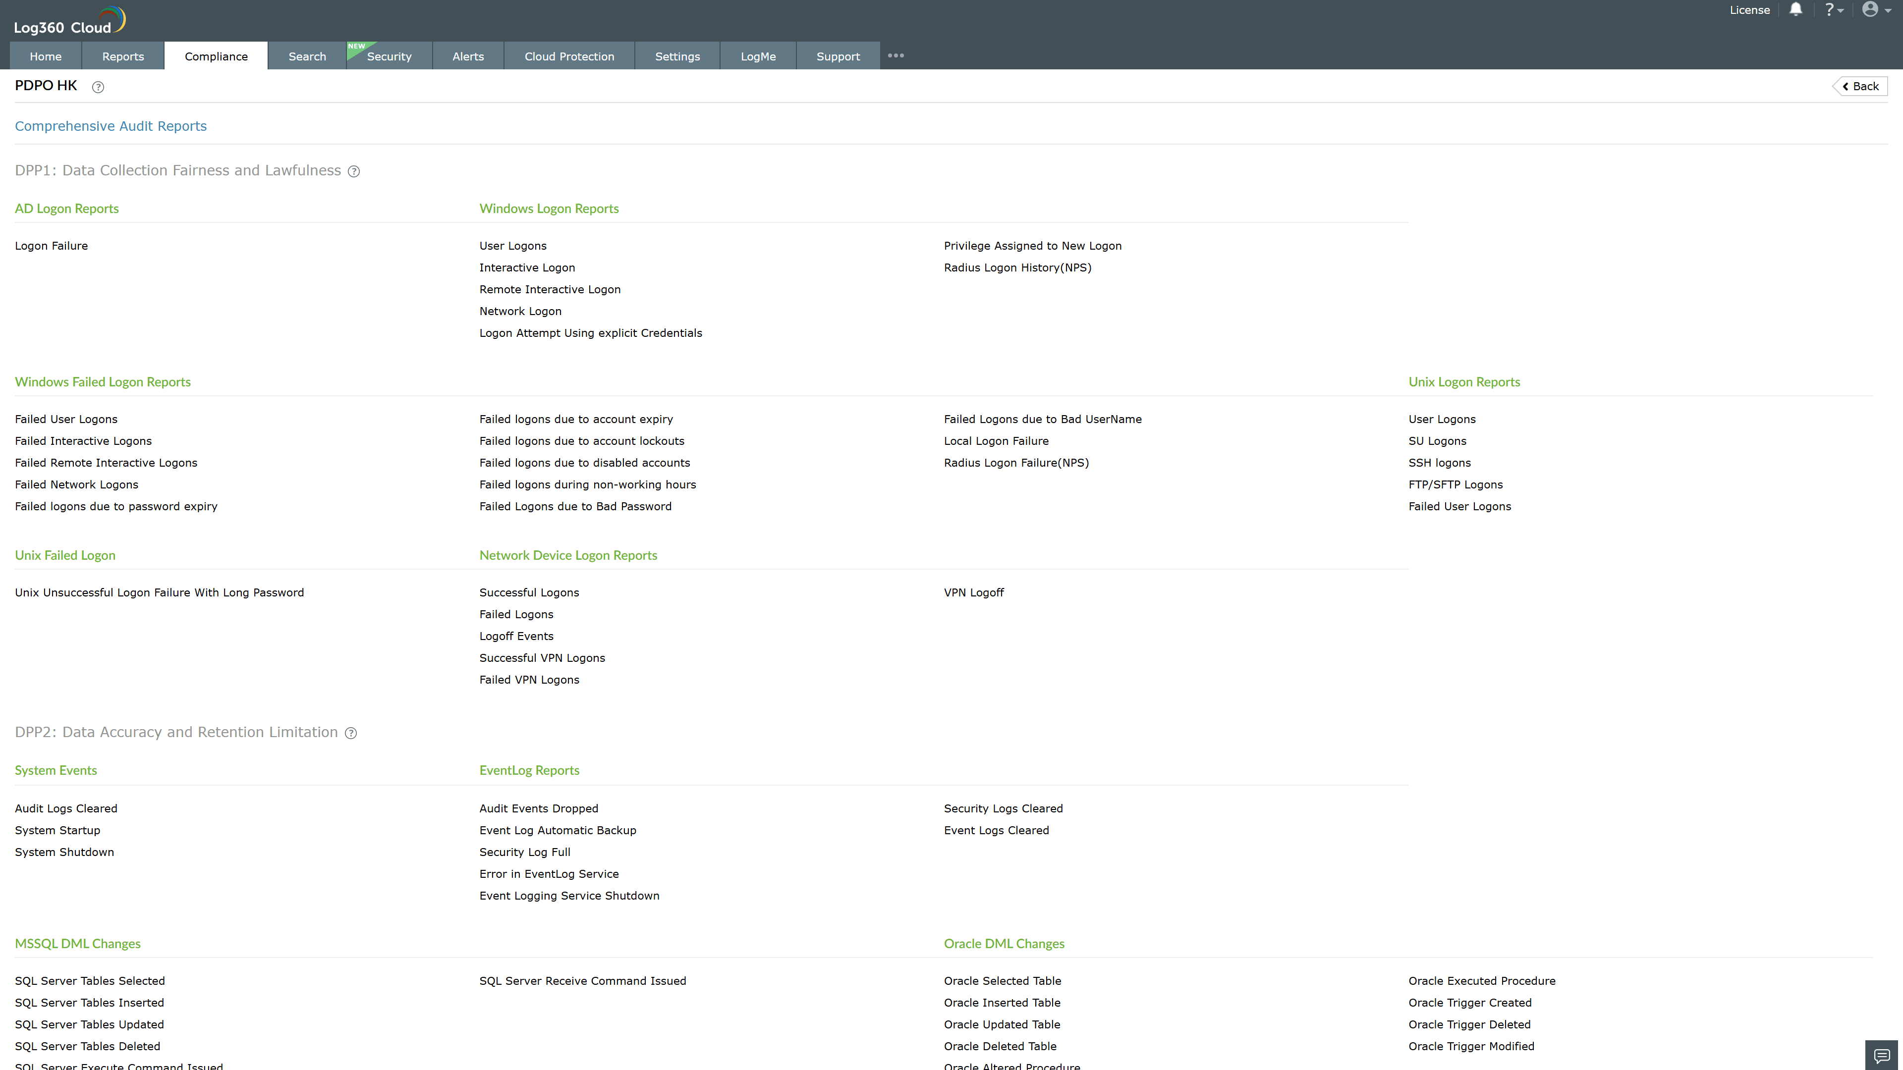
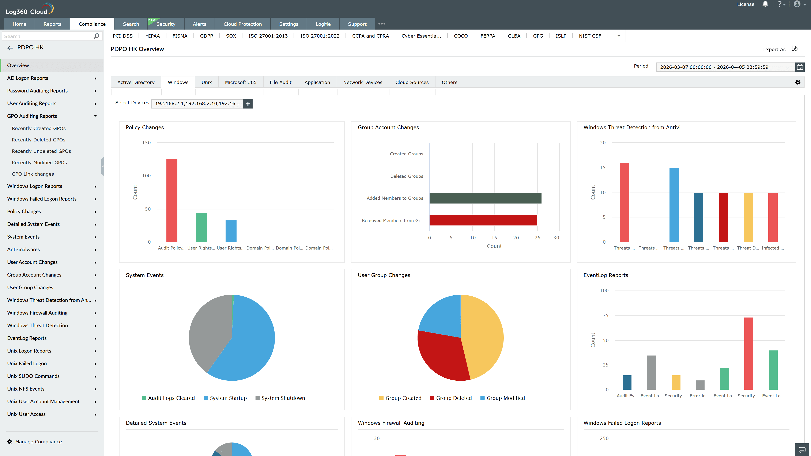
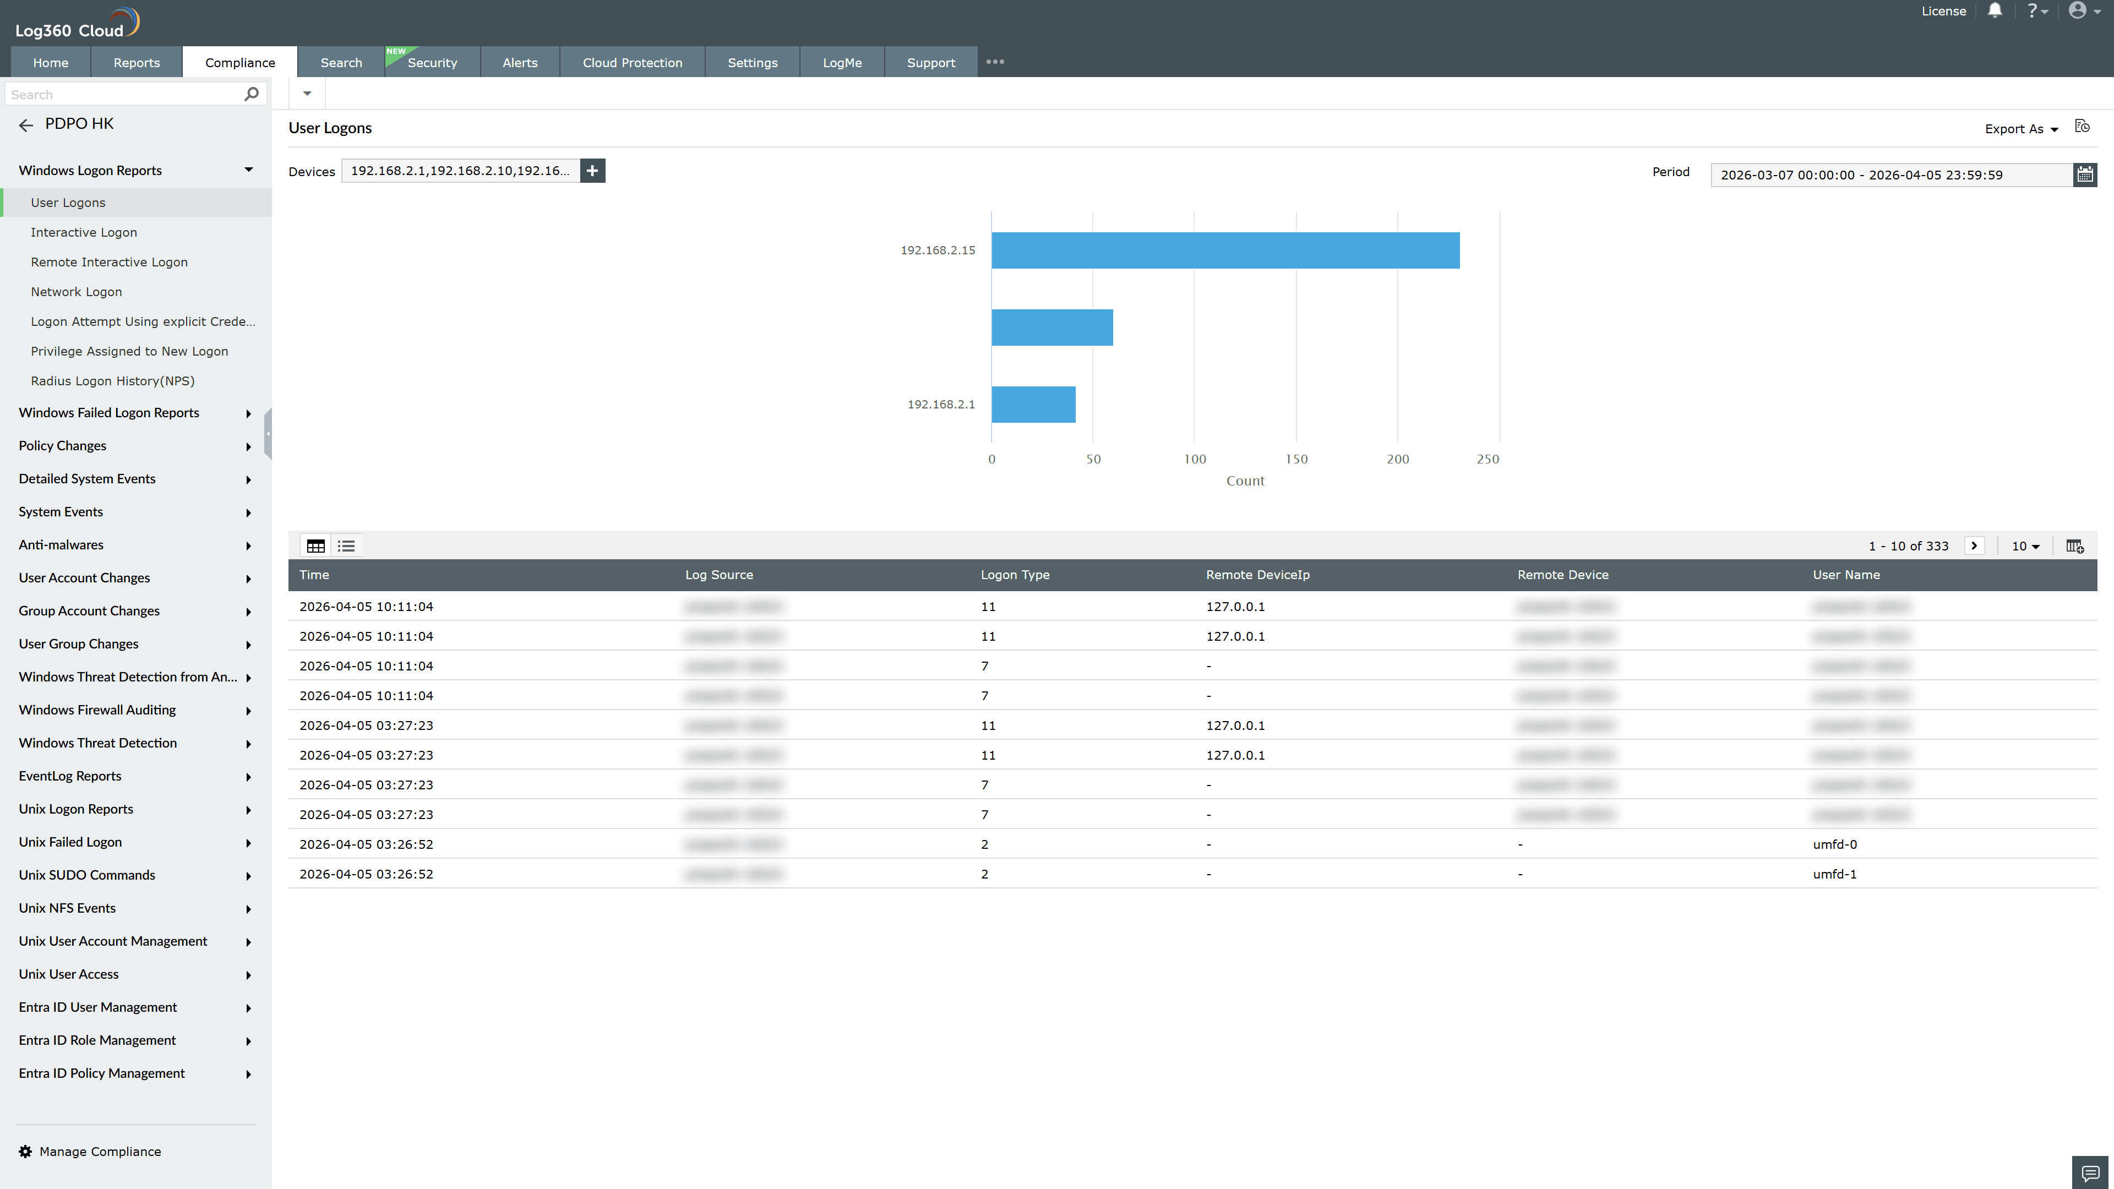
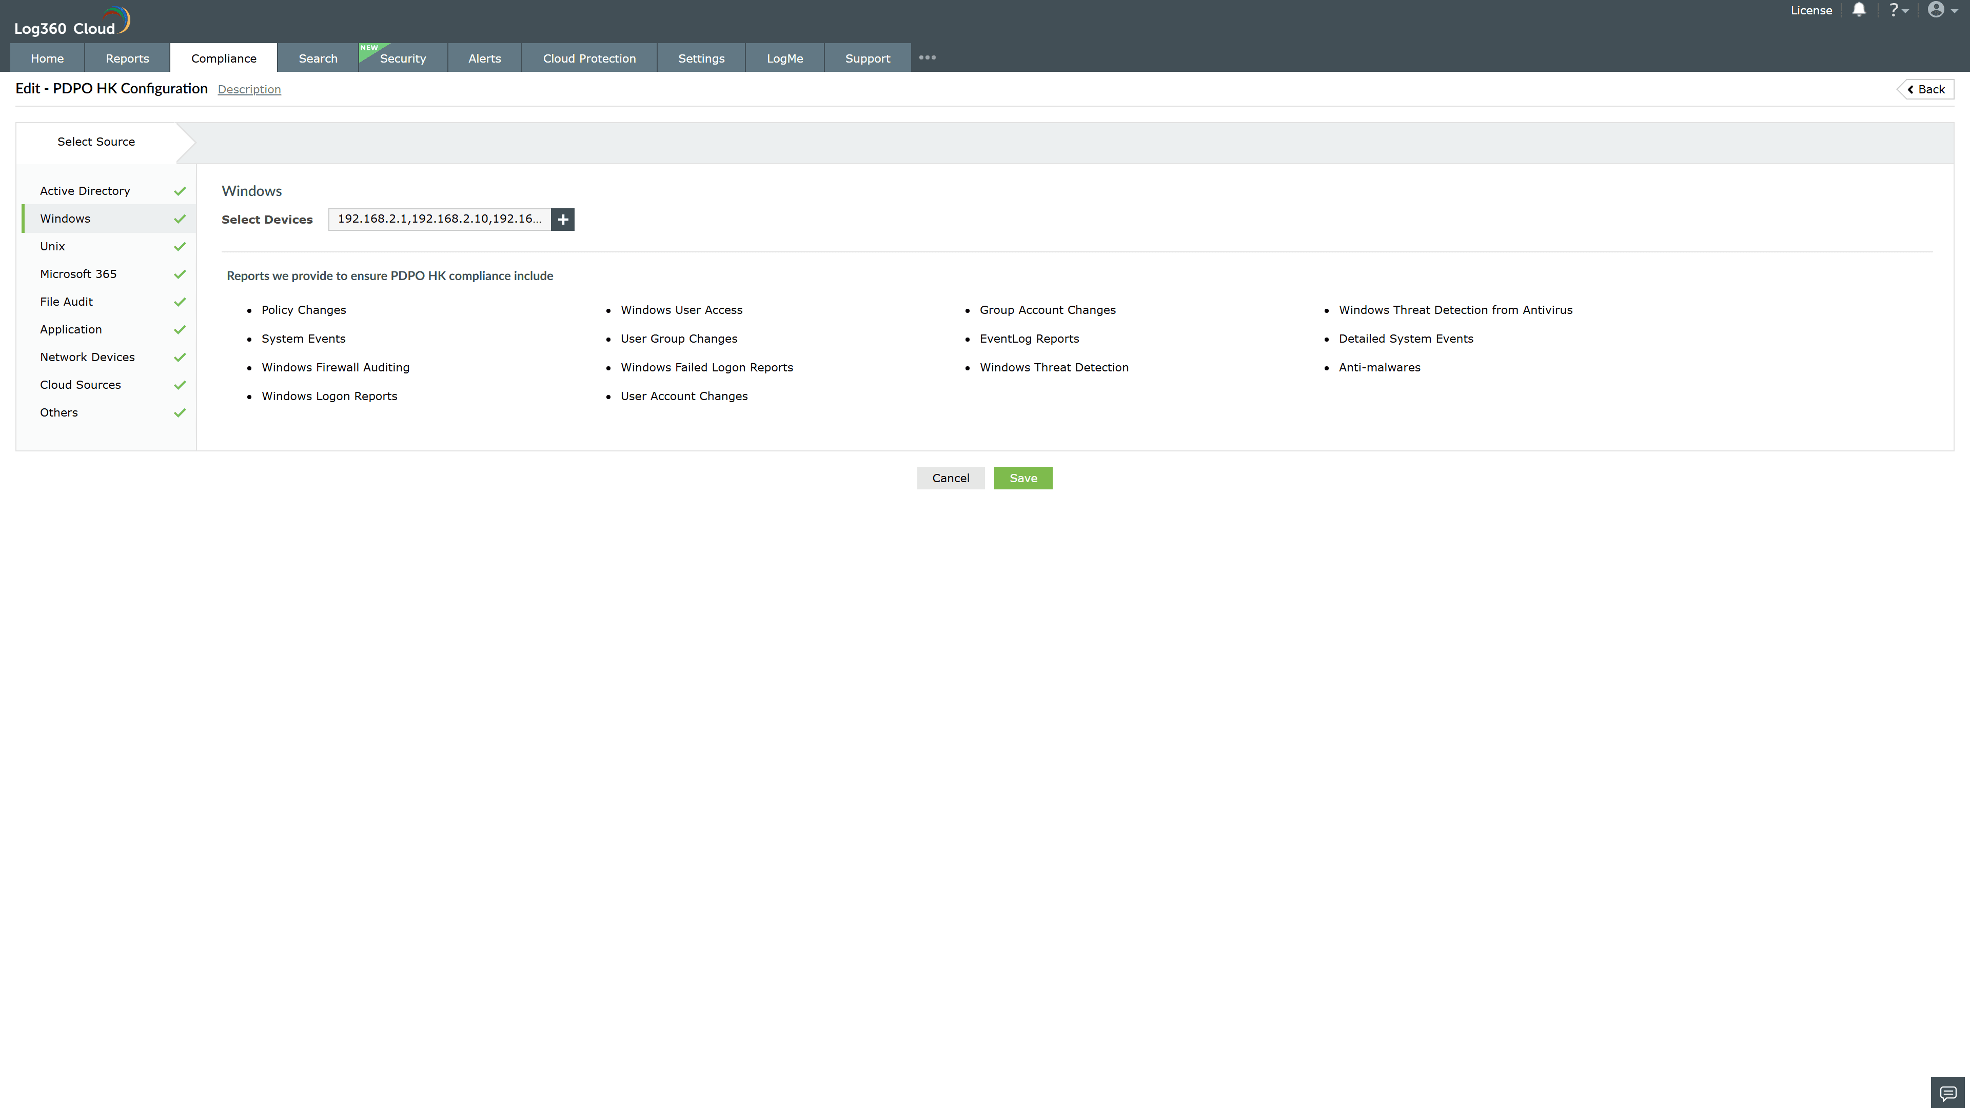
Valid Submission : Yes
Supported Editions : Free, Basic, Standard, Professional, MSSP
Help Document : https://www.manageengine.com/log-management/help/integrations/compliance-extensions.html
Help Video : Not provided
Tags : Log360, Compliance, Privacy monitoring, Data privacy, Regulatory compliance
Supported DCs : US, IN, JP, CA, AU, UK and EU
Privacy Policy:
Terms of Service:
Release Notes:
Predefined reports for the PDPO HK.

